

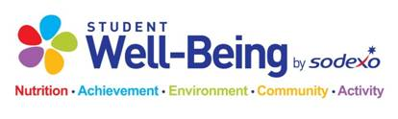

High School Breakfast

September 9th – 13th

Student Breakfast: $1.90

*Tuesday*

Strawberry Banana Smoothie

Bacon, Egg & Cheese English Muffin

Mini Donuts

Assorted Cereal

*Monday*

Muffin Monday

Sausage & Cheese Croissant

Breakfast Cookie

Assorted Cereal

*Thursday*

Cinnamon Toast Crunch Pastry

Egg & Cheese Biscuit

Mini Donuts

Assorted Cereal

*Wednesday*

Bacon Breakfast Pizza

Pancakes & Sausage

Mini Bagels

Assorted Cereal

*Variety of Fruits, Cereal and Cereal Bars Offered Daily*

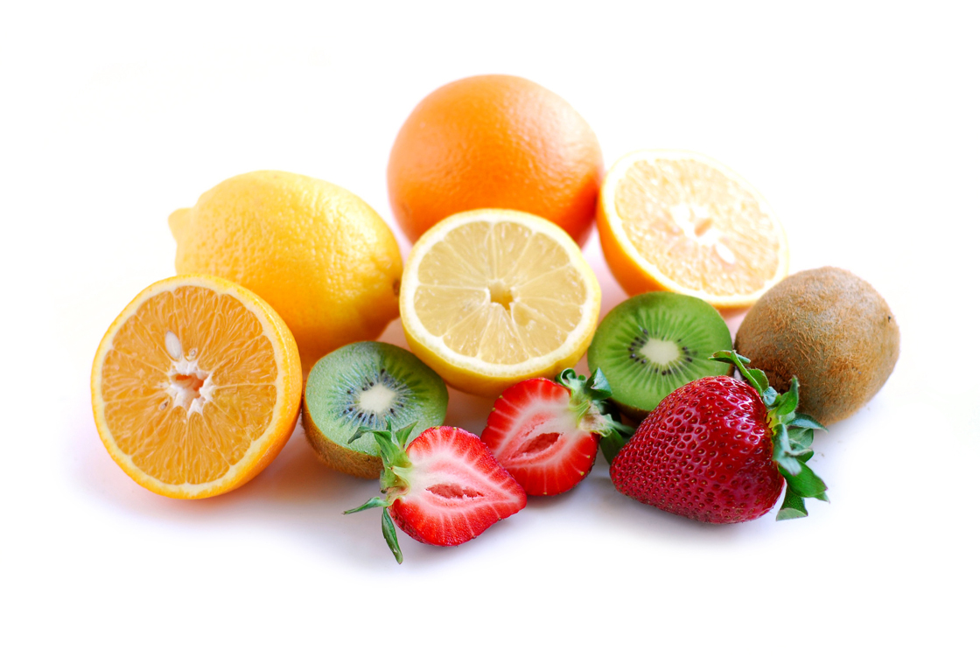

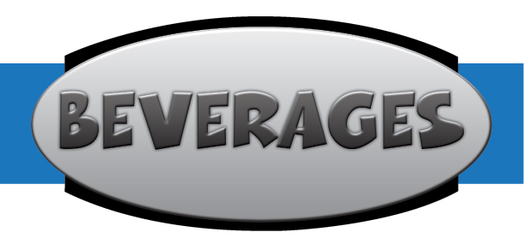

*Friday*

Flatbread Friday!

Double Berry Parfait

Mini Donuts

Assorted Cereal

**Non- Fat Chocolate**

**1% White Milk**

**Skim White Milk**

**Non-discrimination Statement**

The United State Department of Agriculture (USDA) prohibits discrimination in all its programs and activities on the basis of race, color, national origin, gender, religion, age, disability, or marital or family status. To file a complaint of discrimination, call (202) 720-5964 (voice and TDD). USDA is an equal opportunity provider and employer.

To file a complaint of discrimination, write U.S. Department of Agriculture, Director, Office of Adjudication and Compliance, 1400 Independence Avenue, SW, Washington, DC 20250-9410 or cal (800) 795-3272 (voice)   
or (202) 720-6382 (TTY).   USDA is an equal opportunity provider and employer.