

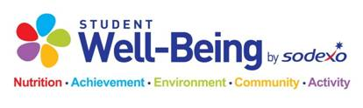

High School Breakfast

September 23rd – 27th   
Student Breakfast: $1.90

*Tuesday*

Strawberry Pineapple Smoothie

Sausage & Cheese English Muffin

Mini Donuts

Assorted Cereal

*Monday*

Muffin Monday

Bacon, Egg & Cheese Croissant

Glazed Donut

Assorted Cereal

*Thursday*

No School

*Wednesday*

Cocoa Puff Pastry

Cheesy Eggs & Biscuit

Blueberry Parfait

Assorted Cereal

*Variety of Fruits, Cereal and Cereal Bars Offered Daily*

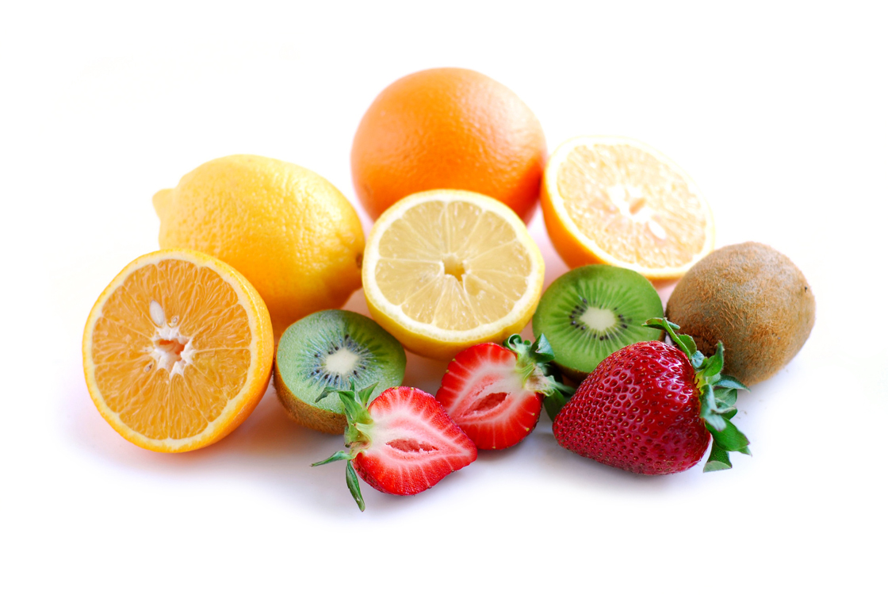

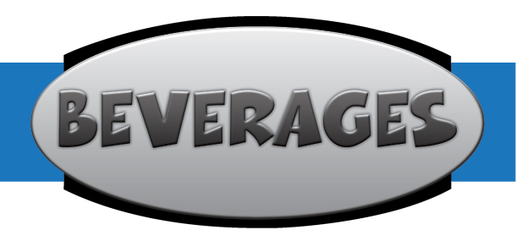

*Friday*

No School

**Non- Fat Chocolate**

**1% White Milk**

**Skim White Milk**

**Non-discrimination Statement**

The United State Department of Agriculture (USDA) prohibits discrimination in all its programs and activities on the basis of race, color, national origin, gender, religion, age, disability, or marital or family status. To file a complaint of discrimination, call (202) 720-5964 (voice and TDD). USDA is an equal opportunity provider and employer.

To file a complaint of discrimination, write U.S. Department of Agriculture, Director, Office of Adjudication and Compliance, 1400 Independence Avenue, SW, Washington, DC 20250-9410 or cal (800) 795-3272 (voice)   
or (202) 720-6382 (TTY).   USDA is an equal opportunity provider and employer.