

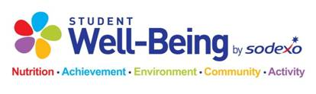

High School Breakfast

September 16th – 20th

Student Breakfast: $1.90

*Tuesday*

Mixed Berry Smoothie

Sausage Pancake Sandwich

Mini Donuts

Assorted Cereal

*Monday*

Muffin Monday

Ham & Cheese English Muffin

Bagel & Cream Cheese

Assorted Cereal

*Thursday*

Bacon, Egg & Cheese Biscuit

Dutch Waffle

Mini Donuts

Assorted Cereal

*Wednesday*

Cinnamon Roll

French Toast Sticks

Strawberry Parfait

Assorted Cereal

*Variety of Fruits, Cereal and Cereal Bars Offered Daily*

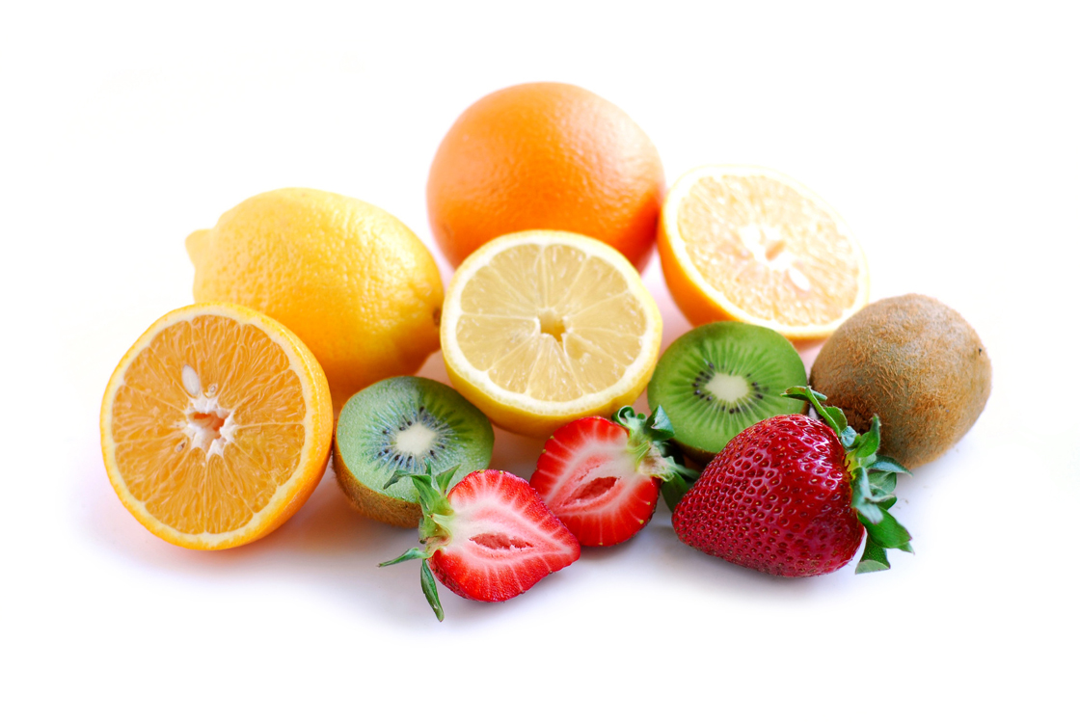

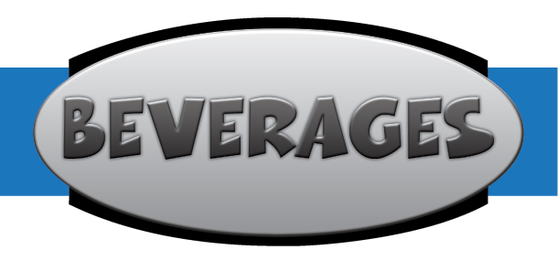

*Friday*

Flatbread Friday!

PB&J Smoothie

Mini Donuts

Assorted Cereal

**Non- Fat Chocolate**

**1% White Milk**

**Skim White Milk**

**Non-discrimination Statement**

The United State Department of Agriculture (USDA) prohibits discrimination in all its programs and activities on the basis of race, color, national origin, gender, religion, age, disability, or marital or family status. To file a complaint of discrimination, call (202) 720-5964 (voice and TDD). USDA is an equal opportunity provider and employer.

To file a complaint of discrimination, write U.S. Department of Agriculture, Director, Office of Adjudication and Compliance, 1400 Independence Avenue, SW, Washington, DC 20250-9410 or cal (800) 795-3272 (voice)   
or (202) 720-6382 (TTY).   USDA is an equal opportunity provider and employer.