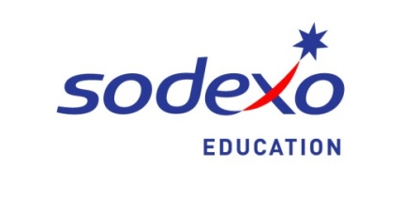
Dear Elkhorn Student Families,

Hello and welcome to another exciting school year! We are delighted to begin another year with some new items in the cafeterias.

Regardless of grade level, your student(s) will have the opportunity for numerous meal choices daily for both breakfast and lunch. All meals meet the current USDA guidelines, and all grade levels have unlimited access to the fruit and vegetable bars with each purchased meal.

Some exciting changes for the school year include some of the following:
- Extended breakfast service at the elementary level. Breakfast will be offered from 7:35 – 8:10 a.m.
- Breakfast in the classroom will be a new option for middle school students who want breakfast but may walk into school with only a few minutes before class begins. Learn more at the Back to School 101 in August.
- A variety of breakfast smoothies and new yogurt parfaits have been added to the menu
- Breakfast will continue to be offered in the high school C-stores each morning. Frozen breakfast smoothies will be offered as a new breakfast option in the C-stores.
- Menu options at the Middle Schools “Explore” bar will feature items such as Wing Bars, Taco Bars, Noodle Bowls and Gyros. These are made to order creations so each student can customize their entrée option.
- “Street Eatz” will be a new station offered at the High Schools daily. Food trucks and the delicious culinary creations continue to grow in popularity. Now students will have a chance to enjoy some of this incredible curbside cuisine right in their very own cafeteria.
- C-Stores at each of the High Schools will open during lunch and offer more express lunch options for those students who prefer to by-pass the traditional serving line. Students will also have the opportunity to visit the C-Store after school, providing opportunity to grab a much needed snack, especially before after-school activities.
- Student Culinary Competitions will be introduced at the secondary level this year promoting student activity, creativity, and education on culinary processes.
- Elementary students will experience the A to Z salad bar, introducing them to fruits and vegetables they may not have tried before.
- Student focus groups will be held each semester to gather input from the students on the Food Service Program.

Your students will experience new and innovative ideas being introduced throughout the school year, continued into future school years as we continually seek new, trendy and nutritious options for the students.

As a reminder, the school payment portal for lunch accounts can be accessed through www.elkhornweb.org and select “lunch” under “district information” tab or directly at www.schoolpaymentportal.com. Here you can deposit money into your student’s accounts via credit card or e-check.

Again, we look forward to a great school year and welcome your input and suggestions.

Sincerely,

Shannon Sintek, General Manager,
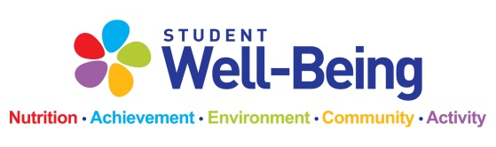
And the Sodexo Food Service Department Team

